**METANACT – Game Manual**

*Seb Holzapfel*

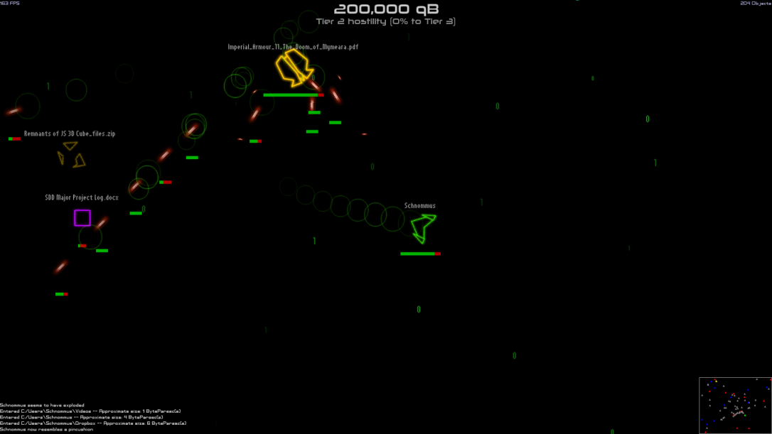

**Overview**

In Metanact, you control a retro-looking spaceship that has been trapped in cyberspace – specifically, your computer’s filesystem! The aim of the game is to obtain as many points (qB) as possible; through collecting scrap: an item commonly found about space, and emitted by enemies as they are destroyed. To get the job done faster, it’s possible to find items: such as weapons or shields, and equip them. To move around, you travel through folder ‘wormholes’.

**Scoring System**

At the top of the game screen is the player’s score UI, which looks like this:



First, there is the player’s actual score, in qB; increased by 10,000 on collecting scrap. Second, there is the current ‘Difficulty tier’, which represents the amount of enemies that may spawn. At tier zero, no enemies will spawn: any tier thereafter, more enemies will spawn and with greater power.

**Minimap**

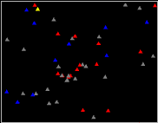

On the bottom-right is a minimap of the current directory: enemies show up in red, wormholes in blue, reversal-wormholes in yellow, yourself in green; and everything else in grey.

**Controls**

* **WASD:** Movement (global or relative dependant on game options)
* **Mouse:** Aim
* **Left Mouse Button:** Shoot (hold for most weapons)
* **E:** Change equipped items (click on items to change them)
* **Escape:** Pause

**Game Options**

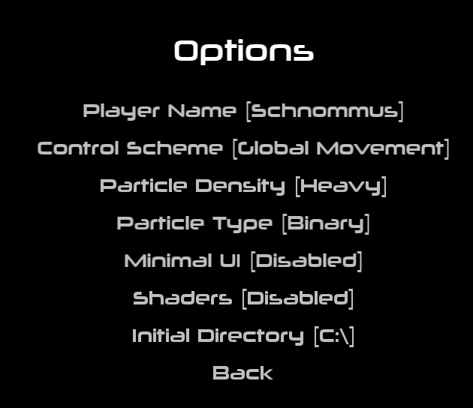

* **Player Name:** Change the text displayed above your ship. (Can do full textual changes by changing options.cfg in the executables directory)
* **Control Scheme:** Global means that W will always move the ship up, Relative means that W will move the ship towards the mouse pointer.
* **Particle Density:** Change the number of particles (Zeros&ones, stars etc). More is slower, but most decent computers can handle ‘heavy’.
* **Particle Type:** If you get bored of zeros & ones you can change the particle type here.
* **Minimal UI:** When enabled, framerate, object count and a log on the bottom left are displayed.
* **Shaders:** Enables a distortion effect around wormholes. Almost halves framerate.
* **Initial directory:** When a new game is started, this is the directory that the player will begin exploring from. (This can be changed further in options.cfg)

**Game Saving**

Metanact will automatically save a game while it is being played; and it can be resumed on any program launch by clicking ‘continue’ instead of ‘new’.

**Things you’ll find**

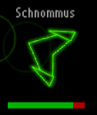

**Your own ship** (of course!)

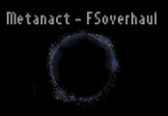

**Wormholes** (For travelling through)

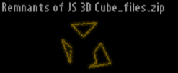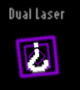

**Scrap & Powerups** (for points and loot)

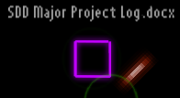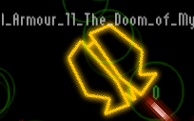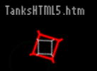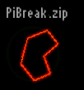

**Enemies** (good for taking fire from)

**The inventory screen**

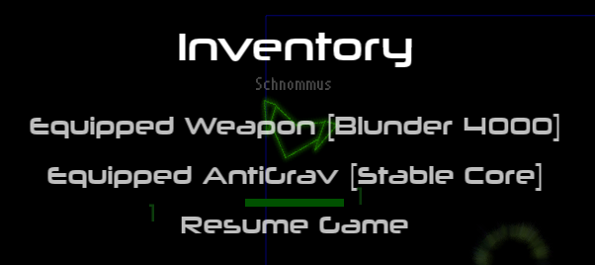

Here, you’re able to change your equipped weapon and antigrav. I won’t digress into the operation of every item however; as that would negate some of the mystery of the game!

**Executing the game**

To execute the game; just run ‘metanact_release.exe’ in the ‘bin’ (binary) folder. The DLLs that the game requires are in the same folder: the game shouldn’t have any other dependencies besides OpenGL and VC++, which is default on windows computer >= XP.